### ***Course Code: CS-1201L***

***Course Name: Introduction to Information and Communication Technology***

***Spring 2021***

***Minerva Candles***

***Project Report By***

***Sana Muhammad Yousuf***

***Group Members:***

***Sana Muhammad Yousuf SE202002***

Table of Contents

***Course Code: CS-1201L*** 1

1. Introduction 3

2. Scope 3

4. Hardware/Software Requirements 4

4.1 Tools 4

4.2 Libraries , IDE 4

5. Screen Shots 4

6. Task List 8

# Introduction

My Project Minerva Candles is a simple yet aesthetic e-commerce website. This website consists of multiple linked web pages featuring different web content and is interactive in nature.

Since this is a vegan and eco-friendly candle store, the color palette used is a mix of different pastels to achieve a soft look and attract customers.

The ordering system is a simple old fashioned form based system.

# Scope

The aim of this project is to deliver a **good looking website** with a **balanced layout**, sufficient **interactiveness** the user can engage in, while using most of the methods and **coding taught in the lab**, and I believe that was **delivered**.

Due to **time constraints** and **debilitating health issues**, I was unable to study in depth to understand the functionality of an add to cart option, and so I couldn’t employ its use in my website. But instead I improvised and came up with an **alternative ordering system** that uses a form and calculates total using JS functions.

Another thing I had planned was to use **format specifiers** for all my form input fields. I tried several times but kept getting **errors**, and due to ongoing health issues I was unable to give enough time to solve these errors.

However, if I were to revisit this project I would definitely make the add to cart option, use proper format specifiers, add more products with image sliders, make the website responsive and use CSS grid layouts instead of divs and tables for the website layout.

1. **Module Description**
2. Home: This is the Homepage and has a navigation bar, intro, testimonial slider, an image that is linked to product page and a footer that consists of click-able social media icons.
3. About Us: This page has a navigation bar, our story with a few hyperlinks, an image and a footer.
4. Products: Navigation bar, three products linked to place order page via buttons, footer.
5. Contact Us: Navigation bar, office addresses and contact us form, footer.
6. Account: Navigation bar, newsletter sign up form, footer.
7. Place Order: Navigation bar, image and place order form with total, footer.

# Hardware/Software Requirements

Project designed on: hp 11” display convertible, Window 10 OS, Intel Core i3 Microprocessor.

## 4.1 Tools

Employed use of HTML5, external and some inline CSS including flex; border box; before after; translate. External JavaScript functions.

## 4.2 Libraries , IDE

Boxicons.com as library for icons, IDE Visual Studio Code

# Screen Shots

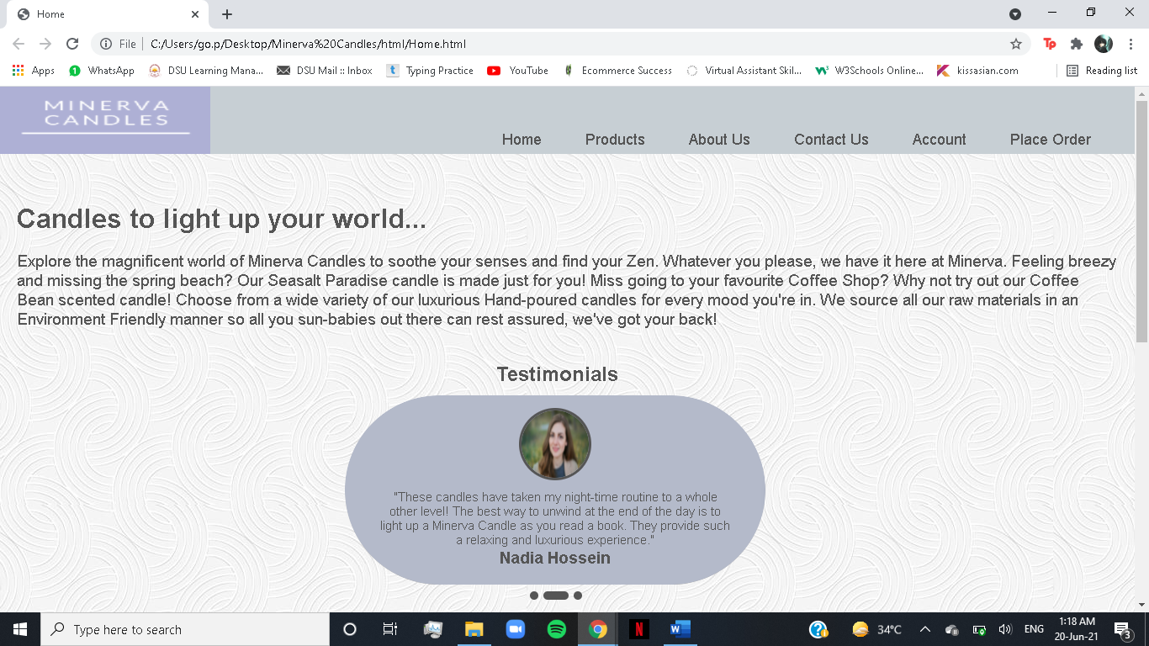

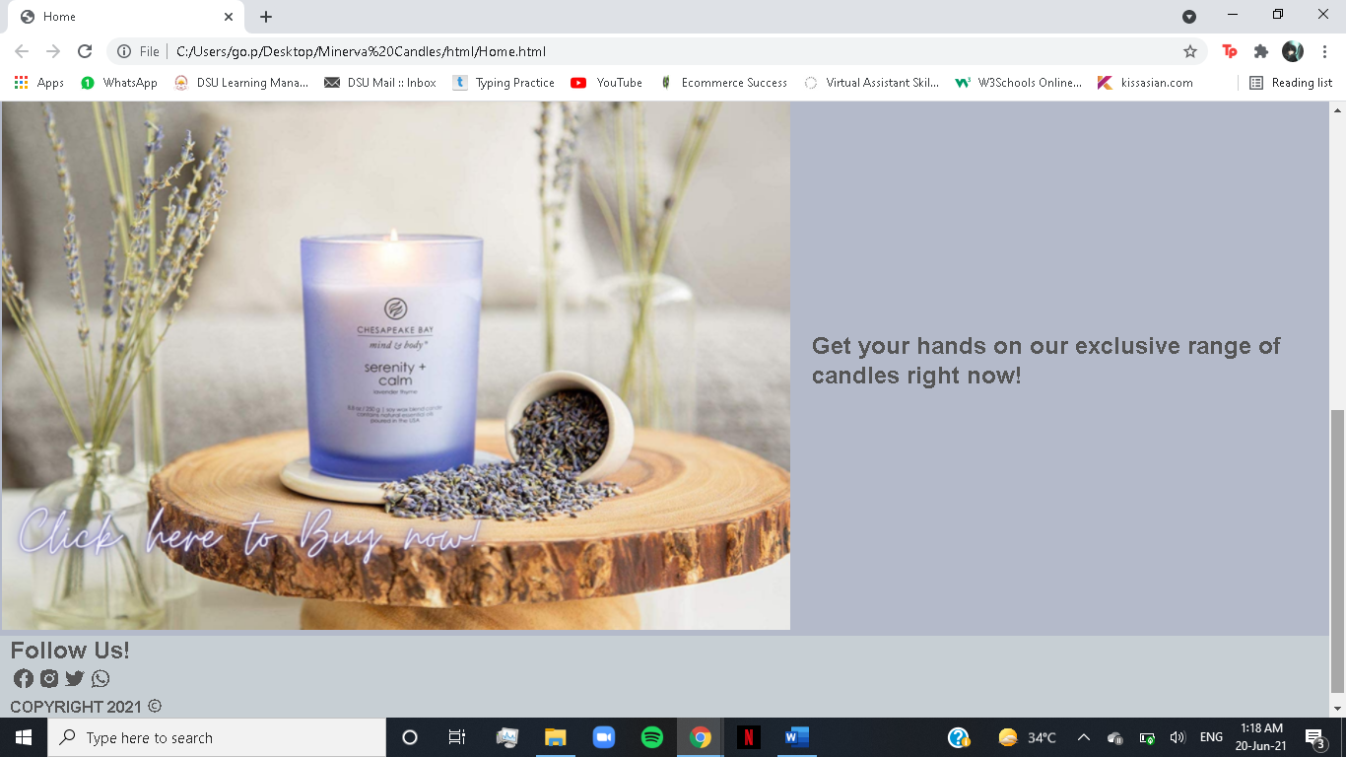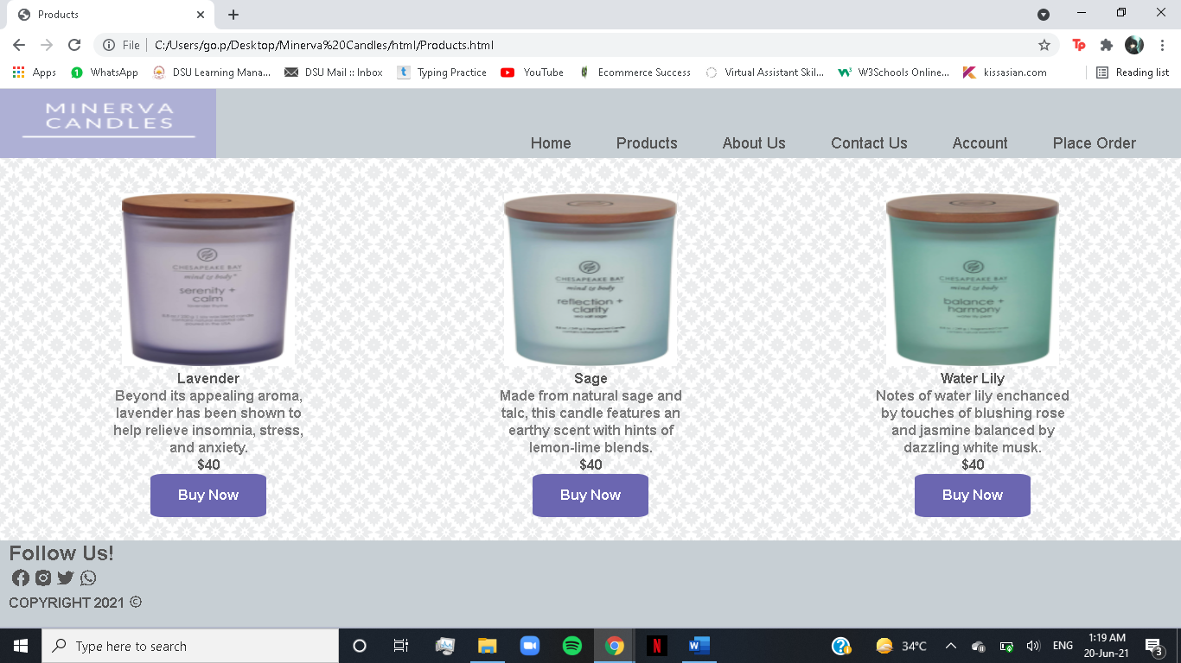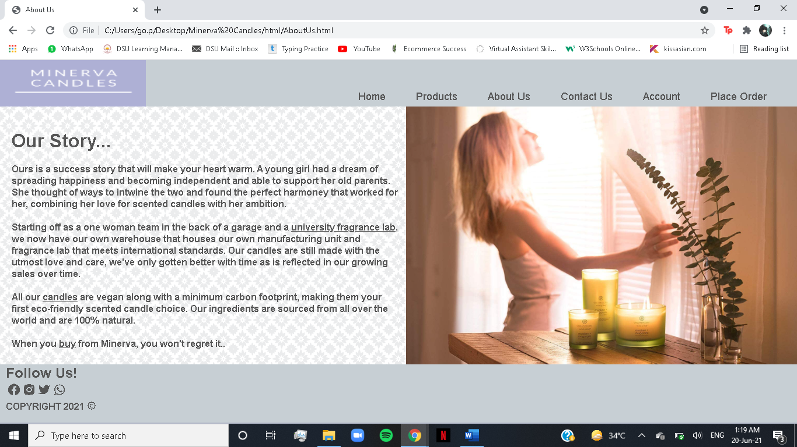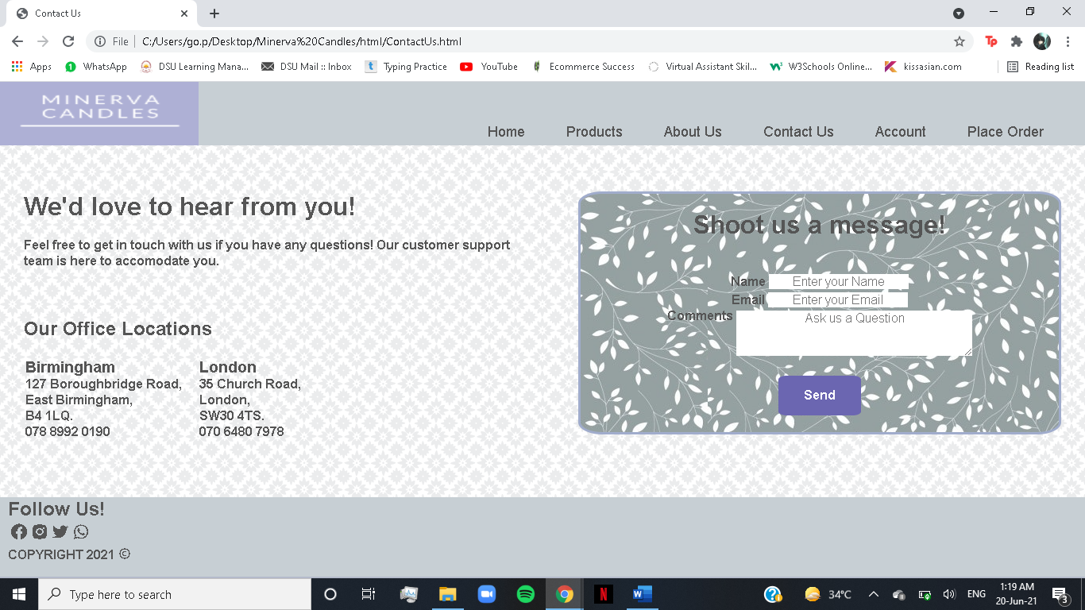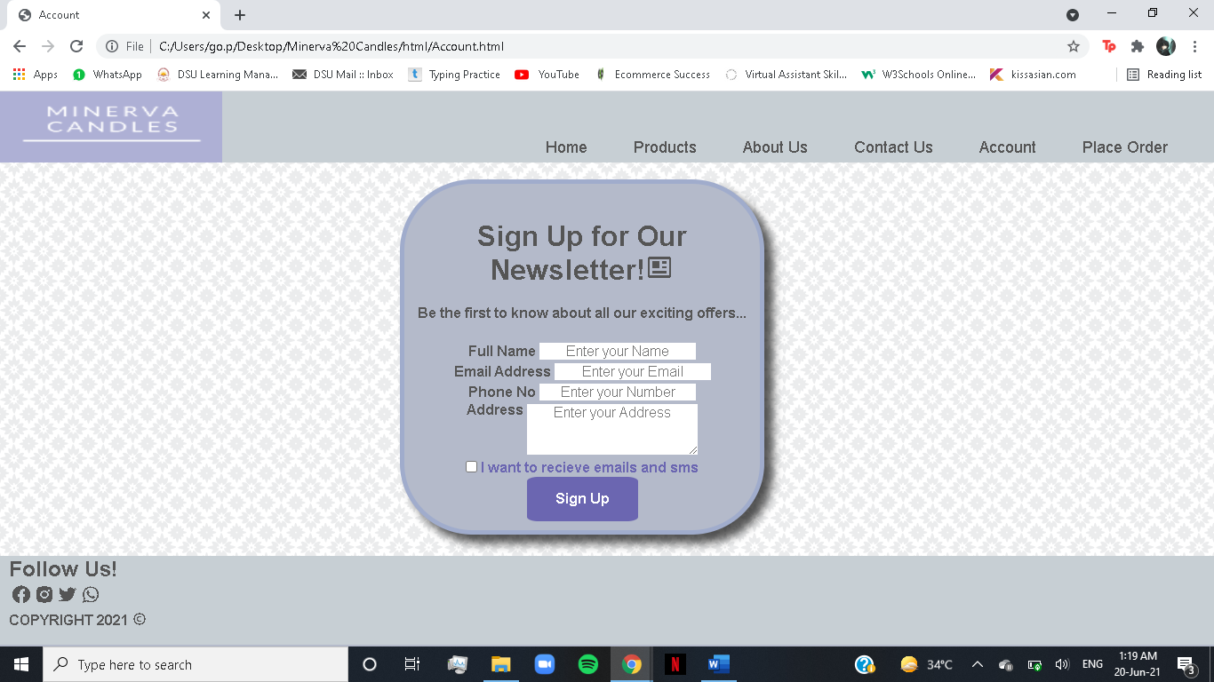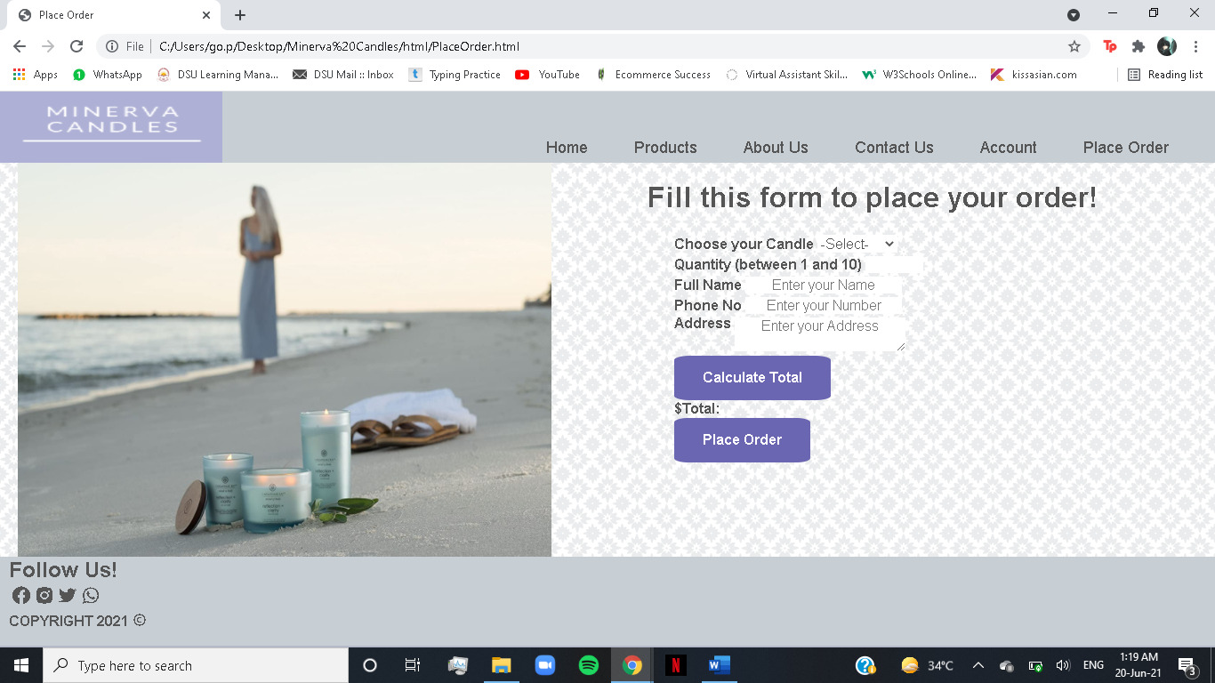

# 6. Task List

1. Home
   1. Navigation bar(code reused on all other pages)
   2. Testimonial slider and it’s CSS and JS
   3. Footer(code reused on all other pages)
2. About Us
   1. Content writing for our story and image using 2 column layout
3. Products
   1. 3 column layout for products, buttons linked to Place Order Page
4. Contact Us
   1. 2 column layout for office address and contact us form
   2. JS form validation
5. Account
   1. Sign up form
   2. JS form validation
6. Place Order
   1. 2 column layout for image and place order form
   2. JS form validation
   3. JS calculate total function